**Programming Lab Exam**

Submitted By: **Jomin K Mathew**

**MCA Semester 1**

**TKM20MCA2021**

**Roll. No :21**

**Question 1:**

Create a class nurses with data members id,name,salary,qualification,covid duty,department and a constructor to initialise them.Create another class Doctor with data members name,specialisation, salary, covid duty, department and a constructor to initialise them. Create a class Hospital derived from Nurses and Doctor with data member hospital id . Each class should have there own display function to display details. Create an object of Hospital and print the details of doctors and nurses engaged in covid duty

**Algorithm :**

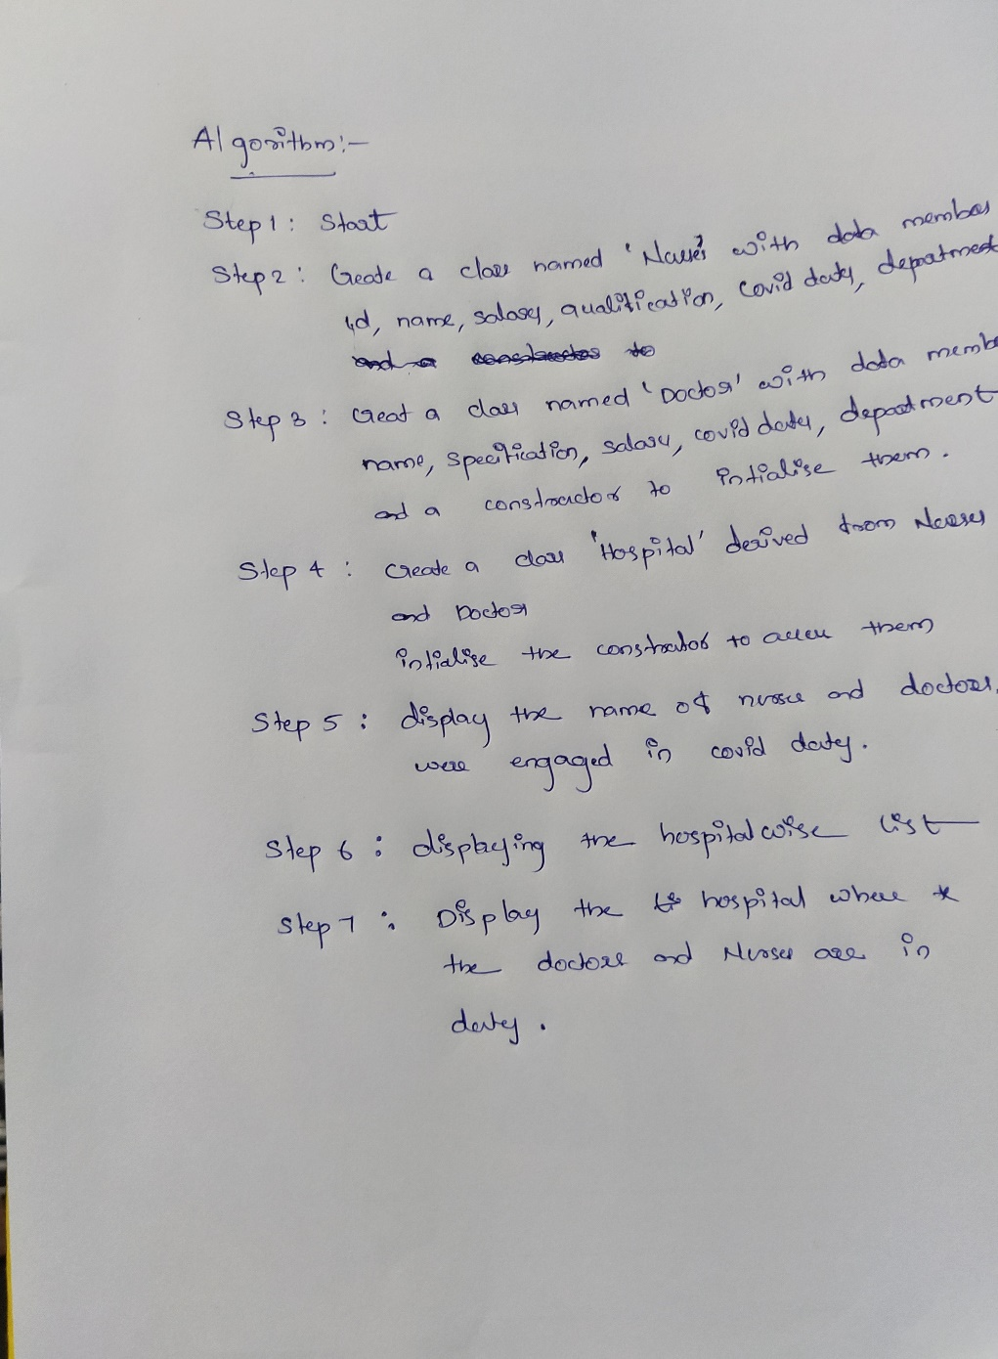

**Programe :**

class Nurses:

def __init__(self):

print("---------Nurses-------")

self.n_memid=int(input("Enter the ID:"))

self.n_name=input("Enter the name:")

self.n_salary=int(input("Enter the salary:"))

self.n_qualif=input("Enter the Qualification:")

self.n_dept=input("Enter the department:")

self.n_covid=input("Are you in Covid Duty(Yes/No):")

def display(self):

print("Member ID:", self.n_memid)

print("Name:",self.n_name)

print("Salary:",self.n_salary)

print("Qualification:",self.n_qualif)

print("Department:",self.n_dept)

print("On Duty:",self.n_covid)

class Doctor:

def __init__(self):

print("---------Doctor-------")

self.d_name=input("Enter the name:")

self.d_salary=int(input("Enter the salary:"))

self.d_specif=input("Enter the Specialization:")

self.d_dept=input("Enter the department:")

self.d_covid=input("Are you in Covid Duty(Yes/No):")

def display(self):

print("Name:",self.d_name)

print("Salary:",self.d_salary)

print("specialization:",self.d_specif)

print("Department:",self.d_dept)

print("On Duty:",self.d_covid)

class hospital(Nurses,Doctor):

def __init__(self,id):

Nurses.__init__(self)

Doctor.__init__(self)

self.h_id=id

def display(self):

if(self.d_covid=='Yes','yes'):

print("Doctor Name:",self.d_name)

if(self.n_covid=='Yes','yes'):

print("Nurse Name:",self.n_name)

id1 =int(input("Enter the hospital ID:"))

s1=hospital(id1)

id2 =int(input("Enter the hospital ID:"))

s2=hospital(id2)

q=int(input("Enter the Hospital Id to check for Covid duty for staff:"))

if(q==id1):

s1.display()

if(q==id2):

s2.display()

**Output :**

